1-SELECT A USER
* DropDown menu is used for user selection.

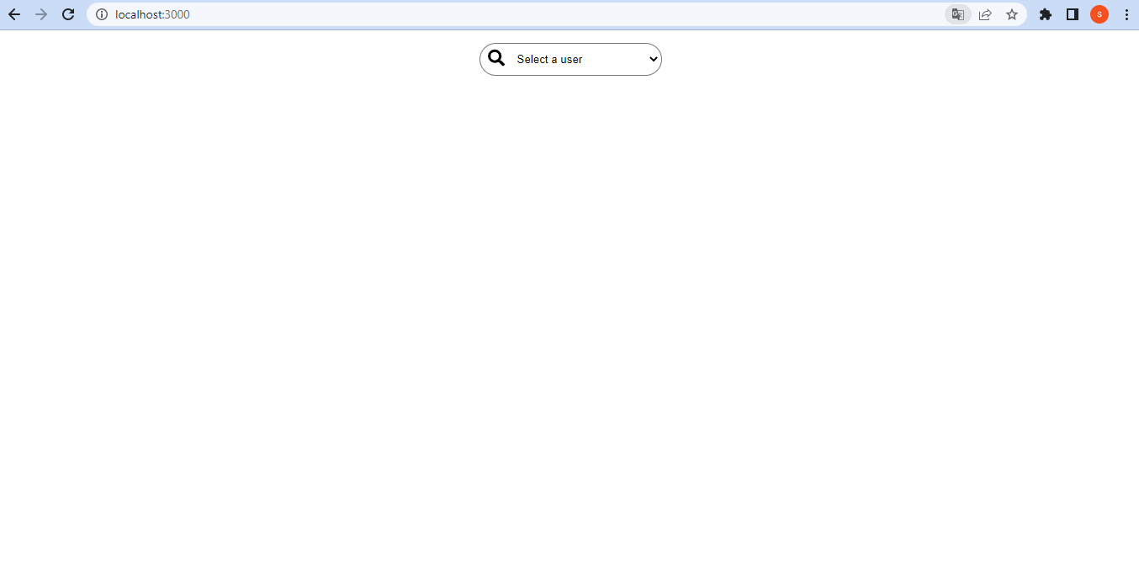
* Users are listed when the DropDown menu is clicked.

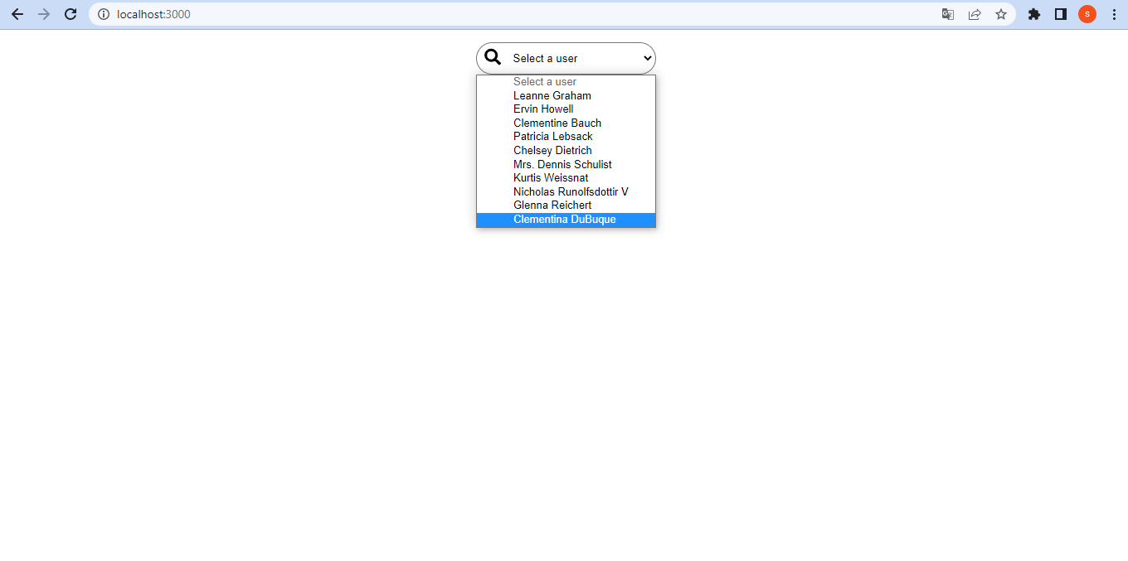

* Posts and Albums page appears when user is selected from the list

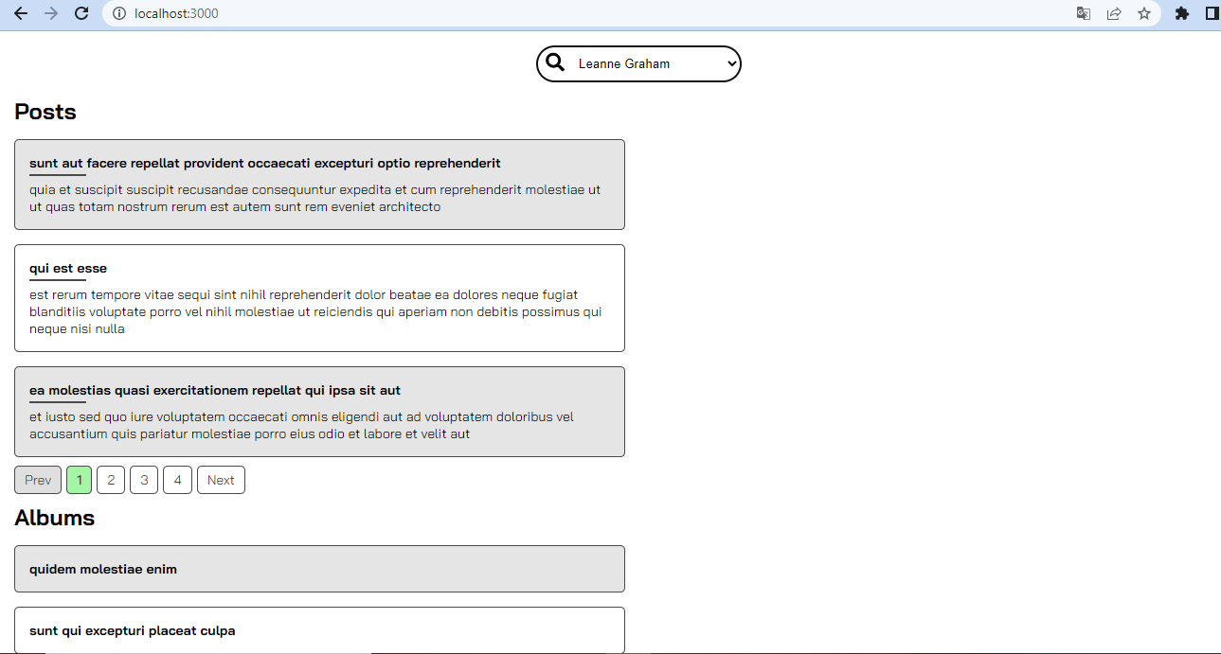

2-POSTS

* When any post is selected, the Comments of that post appear

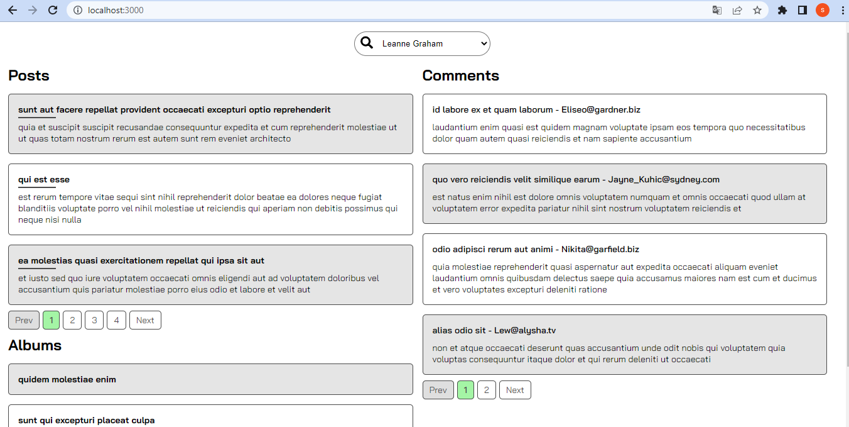

* By paginating Posts and Comments, other pages are accessed.

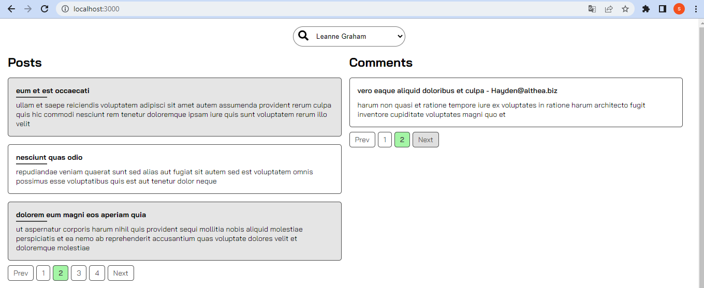

3- ALBUMS

*When any Album is selected, the Photos of that Album appear.

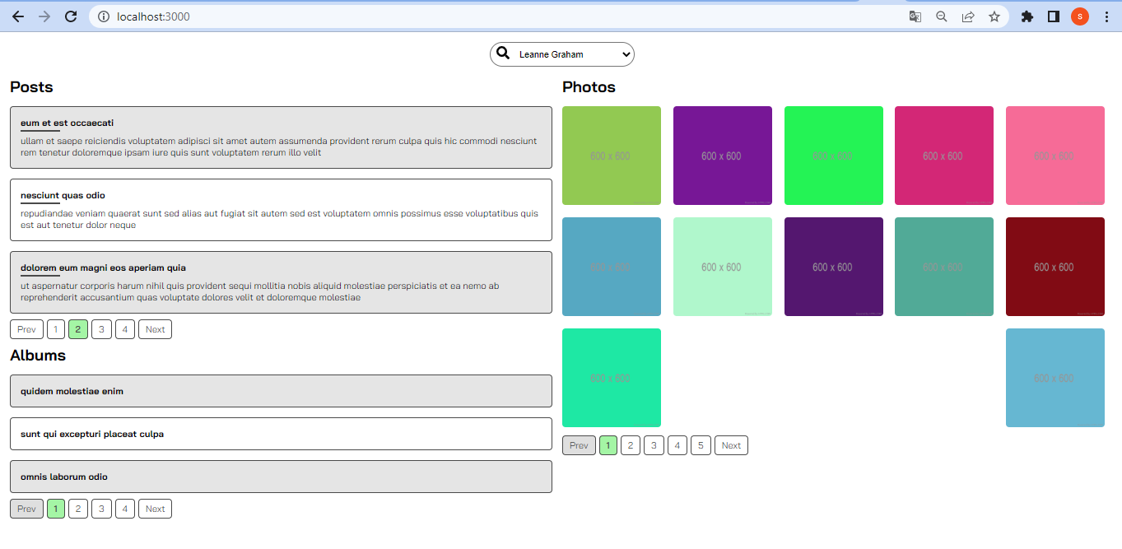

* By paginating Album and Photo larde, other pages are passed.

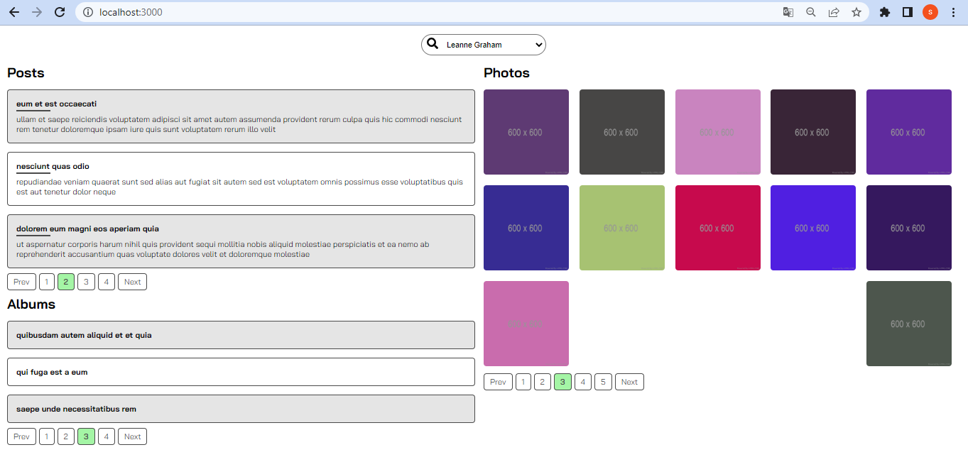

* API CALLS

getToken
getPosts
getAlbum
putPosts
putAlbums
deletePosts
deleteAlbums
postPosts
postAlbums

*BUGS

1-) When a post is selected, it is not understood on the page which post comment is opened;

a. Expected behaviour: When a post is selected, the bar under the post title remains at the length of the title

b. Observed behaviour: The bar lengthens when hovering over a post, but reverts when clicked.

c. Steps to reproduce:

* user is selected.
* Click on the post.
*It is seen that the bar has returned to its former state.

2-)Bir Album seçildiğinde hangi album un photo larının açıldığının sayfada anlaşılmaması;

a. Expected behaviour: When an Album is selected, it is not clear on the page which album's photos are opened;

b. Observed behaviour: When an album is selected, it is not clear to which album the photos appear

c. Steps to reproduce:

* user is selected.
* Click on album.
*Photos open.
*It is not clear which album the photos were opened

**Write a test report from your tests for this project in the following format:

Test cases planned | Test cases executed | Passed/Failed/Skipped | @projePosts
User goes to Project homepage | Go to User Project homepage. | PASSED
Check that the main page is opened. | Checked that the home page is opened. | PASSED
A User is selected. | A User has been selected. | PASSED
The post is selected. | Post selected. | PASSED
When Post is selected, it is checked that the comments field is open | When Post is selected, it is checked that the comments field is open. | PASSED
Click on the last comment on the selected post. | Click on the most recent comment on the selected post. | PASSED
Page closes | The page is closed. | PASSED

Test cases planned | Test cases executed | Passed/Failed/Skipped | @projeAlbum
User goes to Project homepage | Go to User Project homepage. | PASSED
Check that the main page is opened. | Checked that the home page is opened. | PASSED
Another User is selected. | Another User selected | PASSED
Album is the last album on the second page is selected. | Album was selected as the last album on the second page. | PASSED
When Album is selected, it is checked that the photo field is opened. | Checked that the photo field is opened when Album is selected. | PASSED
Click on the first picture in the selected album. | The first picture in the selected album was clicked. | PASSED
Page closes | The page is closed. | PASSED

